

Practices for Secure Software Report

Table of Contents
Document Revision History 3
Client 3
Instructions 3
Developer 4
1. Algorithm Cipher 4
2. Certificate Generation 4
3. Deploy Cipher 4
4. Secure Communications 4
5. Secondary Testing 4
6. Functional Testing 4
7. Summary 4
8. Industry Standard Best Practices 4

Document Revision History

Version | Date | Author | Comments
1.0 | 2/25/26 | Blake Moore

Client



Instructions

Submit this completed practices for secure software report. Replace the bracketed text with the relevant information. You must document your process for writing secure communications and refactoring code that complies with software security testing protocols.

- Respond to the steps outlined below and include your findings.
- Respond using your own words. You may also choose to include images or supporting materials. If you include them, make certain to insert them in all the relevant locations in the document.
- Refer to the Project Two Guidelines and Rubric for more detailed instructions about each section of the template.

Developer
Blake Moore

Algorithm Cipher

I recommend TLS 1.2+ over HTTPS to secure data for Artemis Financial’s web application. Within TLS, the application should rely on asymmetric encryption to negotiate a session securely then use symmetric encryption to protect ongoing communication. TLS provides encrypted and authenticated communication between the client and server. For checksum verification, SHA-256 produces a 256-bit hash value. This allows small changes to input data to result in a completely different output hash. This makes it extremely useful for verifying integrity. AES-256 is the standard for encryption strength. TLS relies on randomness to generate keys. Asymmetric cryptography uses a public/private key pair. This is slower but is good for key exchange and identity. Symmetric cryptography uses a shared key. This is fast and using both together allows strong security. Older algorithms like MD5, SHA-1 and early TLS versions are not recommended now due to known weaknesses. Modern TLS and secure hash functions like SHA-256 are generally seen as the current industry standard.

Certificate Generation
Insert a screenshot below of the CER file.

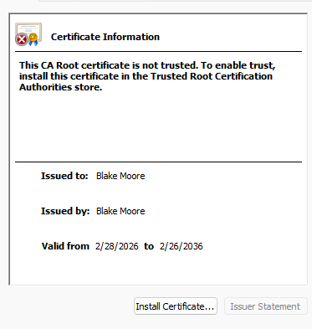

Deploy Cipher
Insert a screenshot below of the checksum verification.

Secure Communications
Insert a screenshot below of the web browser that shows a secure webpage.

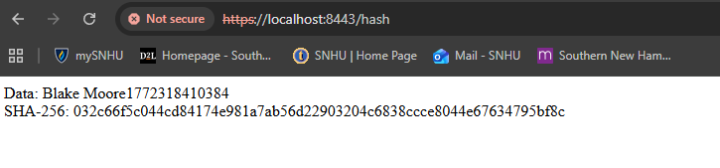

Secondary Testing
Insert screenshots below of the refactored code executed without errors and the dependency-check report.
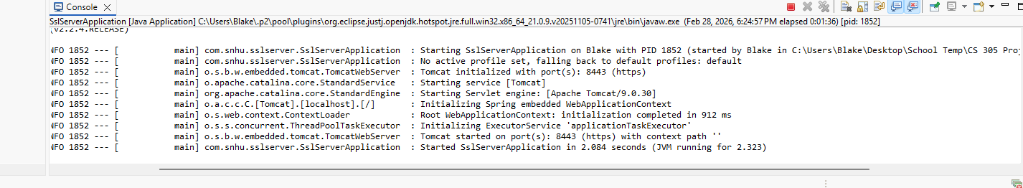
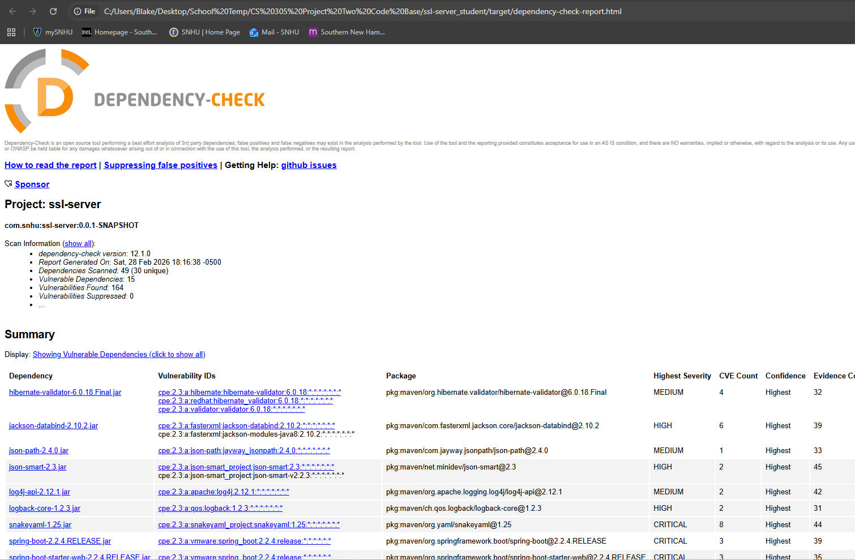

Functional Testing
Insert a screenshot below of the refactored code executed without errors.

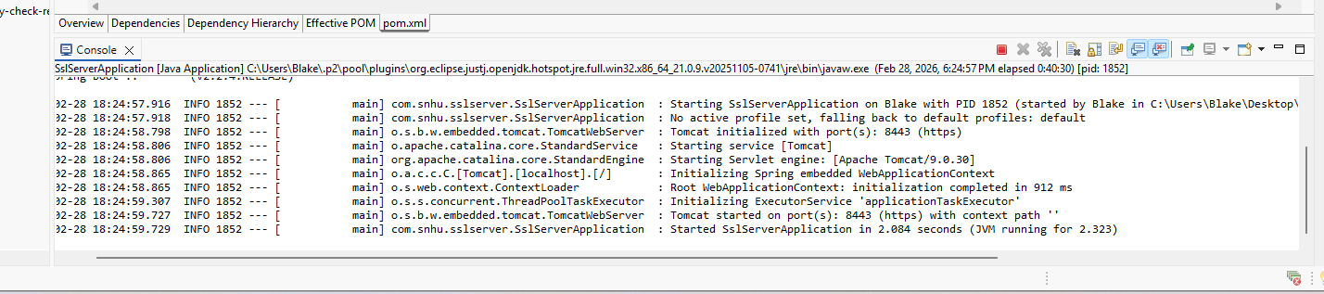

Summary

I refactored the server to have multiple layers of security. First, I generated a self-signed certificate and configured the application to use TLS on port 8443 so data is encrypted and the server endpoint is authenticated. After that I implemented a hash endpoint that produced a SHA-256 checksum for a unique data string. Using this to demonstrate integrity verification. I ran functional testing by executing the refactored application without errors making sure the endpoint loads successfully. I also did a secondary static test using OWASP Dependency check to identify vulnerabilities.

Industry Standard Best Practices

I used industry best practice by implementing HTTPS using TLS to encrypt data and make sure of secure communication between the client and the server. Using certificate-based configuration is standard web security practice for protecting data. I also implemented SHA-256 hashing to make sure of data integrity, which is the standard for checksum verification. Applying industry standard coding practices helps strengthen an organization’s overall security by reducing the risk of data breaches and protects user information. These practices help prevent exploitation of vulnerabilities and ensure that protecting users’ data is a top priority.

